**Project Name:** Earthquake Prediction Model

**Github Link:** https://github.com/projectsforstudents2022/Earthquake_Prediction_Model.git

**Why was this project created?**

One of the most dangerous yet least anticipated natural disasters has been earthquakes. Catastrophic earthquakes cause deaths, extensive infrastructure damage, the quick annihilation of communities, and a precipitous decline in the nation's economy. Ground motion, torrential rain, the composition of the rock bed, regional tectonics, and altitude are just a few of the geographical elements that can trigger an earthquake. Geologists and seismologists are under a lot of pressure to predict the time, location, and intensity of earthquakes.

**What problem is it solving?**

The purpose of earthquake prediction is to alert people in advance of potentially dangerous earthquakes so they can respond to the emergency in a way that minimizes damage to property and human lives.

**Entire explanation of project**

* **PROPOSED APPROACH**

In the suggested studies, various Hadoop data processing technologies are compared. The data acquisition phase makes use of the USGS dataset. The distributed computing algorithm Hadoop is used to process the data. The window data set was divided into two separate sets, a test set and a training set. The training set contains the remaining windows, whereas the test set includes all of the windows for July 2014. Our deep classifier has a large number of trainable parameters. They generalize well to new cases, even if they need a lot of samples from each class to prevent overfitting.

The deep convolutional network in our model predicts whether a window of three-channel waveform seismogram data will be labeled as seismic noise or as an event with its associated geographic cluster. The network's parameters are adjusted to reduce the difference between the genuine labels on the training set and the predicted labels. The percentage of windows that were accurately labeled as earthquake or noise is known as the detection accuracy. All 209 of the events that the OGS has cataloged are effectively detected by our system. The performance of the venue is then assessed. We compare the projected class (1-6) with the geographic label selected from the OGS catalog for each of the detected events. We achieve a location accuracy of 74.5%.

Algorithm for creating next word prediction model :

**Step 1:** Import Libraries & Load Dataset

**Step 2:** Data Preprocessing

**Step 3:** Build Neural Network

**Step 4:** Hyperparameter Tuning

**Step 5:** Train Model

**Step 6:** Testing & Visualization

* **DATA FLOW DIAGRAM**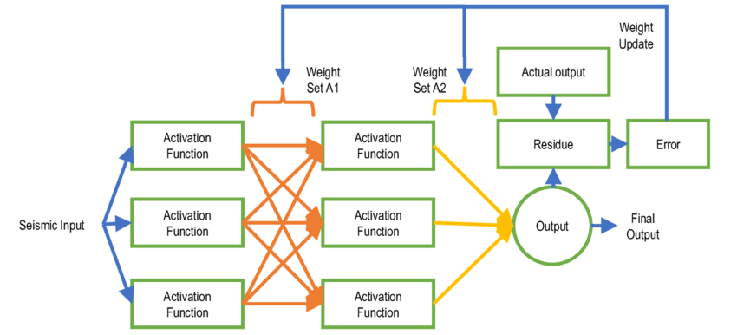
* **RESULT**

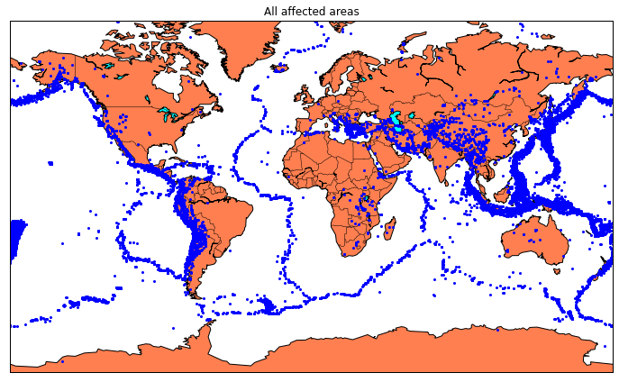

* **CONCLUSION**

As a result, it can be seen that appropriate techniques for issuing earthquake warnings and getting ready for them can be implemented by applying the algorithmic model for earthquake prediction that is given below. With the help of Hadoop, the suggested algorithmic model efficiently analyses data and may be utilized to gather information on earthquakes.